

**“School of Computer Science & Engineering”**

**Lovely Professional University**

**PROJECT REPORT**

**ATM MANAGEMENT SYSTEM**

**PROJECT PARTICIPANTS:**

1. Pentakota Jaswanth (12111901) - Roll.NO.: B61
2. Sathi Akshay Kumar Reddy (12115152) - Roll.NO.: B69
3. Srikanth Narayana (12112069) - Roll.NO.: A10

**PROJECT SUBMITTED TO:**

* **Dr.  Bhimasen Moharana**

**PROJECT TITLE:**

Design an ATM (Automated Teller Machine) Management System software using Java Programming Language. Project shows the working of the ATM in Victual way.

**Contents:**

1. Introduction
2. Objectives
3. Features
4. System Architecture
5. User Interface
6. Application Layer
7. data Access Layer
8. Database Design
9. Programming Language Used
10. Hardware requirements
11. Detailed info of System modules
12. Code of the Project
13. Output of code
14. Data Flow Diagram
15. Use Case Diagram
16. State Transition Diagram
17. ER Diagram
18. Gantt Chart
19. Conclusion

**ACKNOWLEDGEMENT:**

The project work mentioned in this report, is the result of cumulative effort over a period an entire semester in course of which, we have received intellectual support from various sources. It is pleasure to express our profound sense of gratitude to all those who have contributed richly to this project and have been highly instrumental in making this a success. We are highly indebted to our computer lecturer, Dr. Bhimasen Moharanamam for giving us opportunity to work on this project. He has been an invaluable source of guidance and motivation at all stages of our work.

**INTRODUCTION:**

ATM (Automated Teller Machine) Management System is a software application developed in Java language. This system provides the user with the ability to carry out various banking operations like depositing money, withdrawing money, checking balance, changing the PIN, etc. The system is designed to work with any standard ATM machine.

The primary objective of the ATM Management System is to provide a secure and efficient method for customers to carry out banking operations while minimizing errors and frauds in the banking system. The system also aims to reduce the time and effort required by bank employees to process transactions and improve the overall efficiency and accuracy of banking operations.

The system architecture includes a user interface developed using Java Swing, an application layer containing the business logic of the application, including the ATM machine functions and database connectivity, and a data access layer that connects the application to the database storing the account information and transaction history.

The database design includes an account table containing the account information, including the account number, account holder name, balance, and PIN, and a transaction table containing the transaction history, including the account number, transaction type, amount, date, and time.

The system has been developed to minimize the time and effort required by bank employees to process transactions and to improve the efficiency and accuracy of banking operations. The system is designed to minimize errors and frauds in the banking system.

The ATM Management System has a user-friendly interface developed using Java Swing. The system also has a robust database connectivity layer that connects the application to a MySQL database, which stores the account information and transaction history.

In this project, the primary objectives were to develop a system that is easy to use, efficient, and secure. The system allows users to perform various banking operations conveniently and securely. It also ensures the safety of the user's personal and financial information.

Overall, the ATM Management System is a useful software application that enables customers to access their bank accounts conveniently and securely while also improving the efficiency and accuracy of banking operations.

**OBJECTIVES:**

The primary objectives of the ATM Management System are as follows:

1. To provide a convenient and secure method for customers to access their bank accounts
2. To reduce the time and effort required by bank employees to process transactions
3. To improve the efficiency and accuracy of banking operations
4. To minimize errors and frauds in the banking system

**Features:**

The following are the main features of the ATM Management System:

1. User Login: The user can log in to the system by entering a valid ATM card number and PIN.
2. Balance Inquiry: The user can check the balance of their account.
3. Withdrawal: The user can withdraw money from their account, subject to the available balance and withdrawal limit.
4. Deposit: The user can deposit money into their account by inserting cash into the ATM machine.
5. PIN Change: The user can change their PIN for security purposes.
6. Transaction History: The user can view their transaction history, including details such as the date, time, and amount of each transaction.

**System Architecture:**

The ATM Management System has the following architecture:

1. **User Interface:** The user interface is developed using Java Swing.
2. **Application Layer:** This layer contains the business logic of the application, including the ATM machine functions and database connectivity.
3. **Data Access Layer**: This layer connects the application to the database, which stores the account information and transaction history.

**Database Design:**

The ATM Management System uses a MySQL database to store the account information and transaction history. The following tables are created in the database:

1. Account Table: This table contains the account information, including the account number, account holder name, balance, and PIN.
2. Transaction Table: This table contains the transaction history, including the account number, transaction type, amount, date, and time.

**Programming Languages Used:**

In this system we use JAVA Platform for programming language.JAVA Platform means the environment which is used to run program.JAVA is platform independent language since no only single operating system can be required by the java. All the different operating system can execute the java programming language. Java provides huge functionality that means it provide A huge library.

1. Containing lots of reusable codes.
2. An execution environment that provides services such as security
3. Portability across operating system.
4. Automatic garbage collection.

**Hardware Requirements:**

1. Processor: Pentium 4 or onwards.
2. Hard Disc: 80GB.
3. RAM: 128MB.
4. Processor speed: 2.30 GHZ or higher
5. Monitor: 15= Colour Monitor.
6. Mouse.
7. Keyboard.

**Detailed Info of System Modules:**

**1.Cash Withdrawal**:

It mainly used for withdrawal of cash as per customer demand. For any authorized ATM card holder, the ATM system requests for its ATM no &PIN no then customer to login in their accounts, then amounts are given to system and customer can withdraw amount.

**2. Balance Enquiry:**

It refers to enquiry of bank balance of an authorized ATM cardholder account to check for the resulting balance after certain transactions.

**3. Mini Statement:**

It refers to enquiry of last ten transaction of an authorized ATM card holder. It includes deposit & withdrawal amount of transaction & also contains respective transaction date and current available balance.

**4. PIN Change:**

It refers to the Change of PIN no of an authorized ATM cardholder. I

require giving system old PIN no of the ATM card

**5. Cash Deposit:**

It mainly used for deposit cash amount to their bank account as per customer demand. It is easy process of deposit amount to their bank accounts without filling deposit sleep.

**6. Log out:**

After completing all the requirement of their needed user can successfully log out.

**CODE OF ATM MANAGEMENT SYSTEM:**

import java.awt.*;

import java.awt.event.ActionEvent;

import java.awt.event.ActionListener;

import java.awt.event.MouseAdapter;

import java.awt.event.MouseEvent;

import java.util.Random;

import javax.swing.*;

import javax.swing.border.LineBorder;

public class Main {

public static void main(String[] args) {

new password();

}

}

class password extends JFrame

{

public static Dimension size = Toolkit.getDefaultToolkit().getScreenSize();

public static int windowwidth = (int)size.getWidth();

public static int windowheight = (int)size.getHeight();

Label bg;

password()

{

setLayout(null);

setLocation(0,0);

setSize(windowwidth,windowheight);

setExtendedState(MAXIMIZED_BOTH);

setDefaultCloseOperation(EXIT_ON_CLOSE);

Label l1=new Label("Welcome to our ATM ");

l1.setBounds(windowwidth/2-150,50,600,100);

l1.setBackground(new Color(0x00B2FF));

l1.setFont(new Font("Arial",Font.BOLD,40));

l1.setForeground(new Color(0xFFFFFF));

add(l1);

Label l4=new Label("your name :");

l4.setBounds(windowwidth/2-250,150,600,50);

l4.setBackground(new Color(0x00B2FF));

l4.setFont(new Font("Arial",Font.BOLD,20));

l4.setForeground(new Color(0xFFFFFF));

add(l4);

JTextField t3=new JTextField();

t3.setBounds(windowwidth/2-250,220,300,35);

t3.setFont(new Font("Arial",Font.PLAIN,16));

t3.setBorder(new LineBorder(new Color(0x2200FF),2));

add(t3);

Label l2=new Label("card number :");

l2.setBounds(windowwidth/2-250,200+100,600,50);

l2.setBackground(new Color(0x00B2FF));

l2.setFont(new Font("Arial",Font.BOLD,20));

l2.setForeground(new Color(0xFFFFFF));

add(l2);

JTextField t1=new JTextField(12);

t1.setBounds(windowwidth/2-250,260+100,300,35);

t1.setFont(new Font("Arial",Font.PLAIN,16));

t1.setBorder(new LineBorder(new Color(0x2200FF),2));

add(t1);

Label l3 =new Label("pin :");

l3.setBounds(windowwidth/2-250,300+100,600,50);

l3.setBackground(new Color(0x00B2FF));

l3.setFont(new Font("Arial",Font.BOLD,20));

l3.setForeground(new Color(0xFFFFFF));

add(l3);

JTextField t2 =new JPasswordField(4);

t2.setBounds(windowwidth/2-250,360+100,300,35);

t2.setFont(new Font("Arial",Font.PLAIN,16));

t2.setBorder(new LineBorder(new Color(0x2200FF),2));

add(t2);

JButton login=new JButton("login");

login.setBounds(windowwidth/2-250,450+100,200,30);

login.setBackground(new Color(0x13F7FF));

login.setBorder(new LineBorder(new Color(0x13A5FF),2));

login.setFocusPainted(false);

login.setBorderPainted(false);

add(login);

login.addMouseListener(new MouseAdapter() {

@Override

public void mouseEntered(MouseEvent e) {

login.setBackground(new Color(0x13A5FF));

}

@Override

public void mouseExited(MouseEvent e) {

login.setBackground(new Color(0x13F7FF));

}

});

login.addActionListener(new ActionListener() {

@Override

public void actionPerformed(ActionEvent e) {

new home(t3.getText(),t1.getText(),t2.getText());

dispose();

}

});

bg=new Label("");

bg.setBackground(new Color(0x00B2FF));

bg.setBounds(0,0,windowwidth,windowheight);

add(bg);

setVisible(true);

}

}

class home extends JFrame

{

public static Dimension size = Toolkit.getDefaultToolkit().getScreenSize();

public static int windowwidth = (int)size.getWidth();

public static int windowheight = (int)size.getHeight();

Label bg;

int n=124500;

home(String name,String cn,String pin)

{

setLayout(null);

setLocation(0,0);

setSize(windowwidth,windowheight);

setExtendedState(MAXIMIZED_BOTH);

setDefaultCloseOperation(EXIT_ON_CLOSE);

Label atm=new Label("ATM");

atm.setBounds(50,10,300,100);

atm.setFont(new Font("Arial", Font.BOLD,30));

atm.setBackground(new Color(0x0049B0));

atm.setForeground(new Color(0xffffff));

add(atm);

Label l1=new Label("welcome : ");

l1.setBackground(new Color(0x0049B0));

l1.setForeground(new Color(0x6FB7FF));

l1.setFont(new Font("Arial", Font.PLAIN,18));

l1.setBounds(50,300,400,30);

add(l1);

Label l2 =new Label(name);

l2.setBackground(new Color(0x0049B0));

l2.setForeground(new Color(0xFFFFFF));

l2.setFont(new Font("Arial", Font.BOLD,24));

l2.setBounds(50,330,400,50);

add(l2);

Label l3 =new Label("savings #");

l3.setBackground(new Color(0x0049B0));

l3.setForeground(new Color(0x6FB7FF));

l3.setFont(new Font("Arial", Font.PLAIN,18));

l3.setBounds(50,400,400,30);

add(l3);

Label l4 =new Label("$124500");

l4.setBackground(new Color(0x0049B0));

l4.setForeground(new Color(0xFFFFFF));

l4.setFont(new Font("Arial", Font.BOLD,30));

l4.setBounds(50,430,400,50);

add(l4);

JButton b1=new JButton("Deposit");

b1.setBounds(windowwidth/2-200,200,300,100);

b1.setFont(new Font("Arial",Font.PLAIN,18));

b1.setForeground(new Color(0xffffff));

b1.setFocusPainted(false);

b1.setBorderPainted(false);

b1.setBackground(new Color(0x3AD8FD));

add(b1);

b1.addMouseListener(new MouseAdapter() {

@Override

public void mouseEntered(MouseEvent e) {

b1.setBackground(new Color(0x02BCFF));

}

@Override

public void mouseExited(MouseEvent e) {

b1.setBackground(new Color(0x3AD8FD));

}

});

b1.addActionListener(new ActionListener() {

@Override

public void actionPerformed(ActionEvent e) {

JFrame f= new JFrame("deposit");

f.setLocation(windowwidth/2-150,windowheight/2-250);

f.setSize(300,500);

f.setResizable(false);

Label l1=new Label("enter amount : ");

l1.setForeground(new Color(0xffffff));

l1.setFont(new Font("Arial", Font.PLAIN,18));

l1.setBackground(new Color(0x0049B0));

l1.setBounds(30,40,200,50);

f.add(l1);

JTextField t1=new JTextField();

t1.setBounds(30,100,240,30);

t1.setBackground(new Color(0x0049B0));

t1.setBorder(new LineBorder(new Color(0xffffff),2));

t1.setFont(new Font("Arial", Font.PLAIN,16));

t1.setForeground(new Color(0xffffff));

f.add(t1);

Label l2 =new Label("Re-enter amount : ");

l2.setForeground(new Color(0xffffff));

l2.setFont(new Font("Arial", Font.PLAIN,18));

l2.setBackground(new Color(0x0049B0));

l2.setBounds(30,140,200,50);

f.add(l2);

JTextField t2 =new JTextField();

t2.setBounds(30,200,240,30);

t2.setBackground(new Color(0x0049B0));

t2.setBorder(new LineBorder(new Color(0xffffff),2));

t2.setFont(new Font("Arial", Font.PLAIN,16));

t2.setForeground(new Color(0xffffff));

f.add(t2);

JButton dep=new JButton("Deposit");

dep.setBounds(30,270,240,30);

dep.setBackground(new Color(0x02BCFF));

dep.setForeground(new Color(0xffffff));

dep.setFont(new Font("Arial", Font.PLAIN,20));

dep.setFocusPainted(false);

dep.setBorderPainted(false);

f.add(dep);

dep.addMouseListener(new MouseAdapter() {

@Override

public void mouseEntered(MouseEvent e) {

dep.setBackground(new Color(0x02BCFF));

}

@Override

public void mouseExited(MouseEvent e) {

dep.setBackground(new Color(0x02BCFF));

}

});

dep.addActionListener(new ActionListener() {

@Override

public void actionPerformed(ActionEvent e) {

if(t1.getText().equals(t2.getText()))

{

JOptionPane.showMessageDialog(null,"your amount is successfully deposited.");

n+= Integer.parseInt(t1.getText());

l4.setText("$"+n);

f.dispose();

}

else

{

JOptionPane.showMessageDialog(null,"enter same amount in both fields.");

}

}

});

Label bg=new Label("");

bg.setBounds(0,0,300,400);

bg.setBackground(new Color(0x0049B0));

f.add(bg);

f.setVisible(true);

}

});

JButton b2 =new JButton("Change Password");

b2.setBounds(windowwidth/2+200,200,300,100);

b2.setFont(new Font("Arial",Font.PLAIN,18));

b2.setForeground(new Color(0xffffff));

b2.setFocusPainted(false);

b2.setBorderPainted(false);

b2.setBackground(new Color(0x3AD8FD));

add(b2);

b2.addMouseListener(new MouseAdapter() {

@Override

public void mouseEntered(MouseEvent e) {

b2.setBackground(new Color(0x02BCFF));

}

@Override

public void mouseExited(MouseEvent e) {

b2.setBackground(new Color(0x3AD8FD));

}

});

b2.addActionListener(new ActionListener() {

@Override

public void actionPerformed(ActionEvent e) {

JFrame f= new JFrame("deposit");

f.setLocation(windowwidth/2-150,windowheight/2-250);

f.setSize(300,500);

f.setResizable(false);

Label l1=new Label("enter new pin : ");

l1.setForeground(new Color(0xffffff));

l1.setFont(new Font("Arial", Font.PLAIN,18));

l1.setBackground(new Color(0x0049B0));

l1.setBounds(30,40,200,50);

f.add(l1);

JTextField t1=new JPasswordField();

t1.setBounds(30,100,240,30);

t1.setBackground(new Color(0x0049B0));

t1.setBorder(new LineBorder(new Color(0xffffff),2));

t1.setFont(new Font("Arial", Font.PLAIN,16));

t1.setForeground(new Color(0xffffff));

f.add(t1);

Label l2 =new Label("Re-enter pin : ");

l2.setForeground(new Color(0xffffff));

l2.setFont(new Font("Arial", Font.PLAIN,18));

l2.setBackground(new Color(0x0049B0));

l2.setBounds(30,140,200,50);

f.add(l2);

JTextField t2 =new JPasswordField();

t2.setBounds(30,200,240,30);

t2.setBackground(new Color(0x0049B0));

t2.setBorder(new LineBorder(new Color(0xffffff),2));

t2.setFont(new Font("Arial", Font.PLAIN,16));

t2.setForeground(new Color(0xffffff));

f.add(t2);

JButton dep=new JButton("Change");

dep.setBounds(30,270,240,30);

dep.setBackground(new Color(0x02BCFF));

dep.setForeground(new Color(0xffffff));

dep.setFont(new Font("Arial", Font.PLAIN,20));

dep.setFocusPainted(false);

dep.setBorderPainted(false);

f.add(dep);

dep.addMouseListener(new MouseAdapter() {

@Override

public void mouseEntered(MouseEvent e) {

dep.setBackground(new Color(0x02BCFF));

}

@Override

public void mouseExited(MouseEvent e) {

dep.setBackground(new Color(0x02BCFF));

}

});

dep.addActionListener(new ActionListener() {

@Override

public void actionPerformed(ActionEvent e) {

if(t1.getText().equals(t2.getText()))

{

JOptionPane.showMessageDialog(null,"your password is successfully changed.");

f.dispose();

}

else

{

JOptionPane.showMessageDialog(null,"enter same pin in both fields.");

}

}

});

Label bg=new Label("");

bg.setBounds(0,0,300,400);

bg.setBackground(new Color(0x0049B0));

f.add(bg);

f.setVisible(true);

}

});

JButton b3 =new JButton("Withdraw");

b3.setBounds(windowwidth/2-200,350,300,100);

b3.setFont(new Font("Arial",Font.PLAIN,18));

b3.setForeground(new Color(0xffffff));

b3.setFocusPainted(false);

b3.setBorderPainted(false);

b3.setBackground(new Color(0x3AD8FD));

add(b3);

b3.addMouseListener(new MouseAdapter() {

@Override

public void mouseEntered(MouseEvent e) {

b3.setBackground(new Color(0x02BCFF));

}

@Override

public void mouseExited(MouseEvent e) {

b3.setBackground(new Color(0x3AD8FD));

}

});

b3.addActionListener(new ActionListener() {

@Override

public void actionPerformed(ActionEvent e) {

JFrame f= new JFrame("deposit");

f.setLocation(windowwidth/2-150,windowheight/2-250);

f.setSize(300,500);

f.setResizable(false);

Label l1=new Label("enter amount : ");

l1.setForeground(new Color(0xffffff));

l1.setFont(new Font("Arial", Font.PLAIN,18));

l1.setBackground(new Color(0x0049B0));

l1.setBounds(30,40,200,50);

f.add(l1);

JTextField t1=new JTextField();

t1.setBounds(30,100,240,30);

t1.setBackground(new Color(0x0049B0));

t1.setBorder(new LineBorder(new Color(0xffffff),2));

t1.setFont(new Font("Arial", Font.PLAIN,16));

t1.setForeground(new Color(0xffffff));

f.add(t1);

Label l2 =new Label("Re-enter amount : ");

l2.setForeground(new Color(0xffffff));

l2.setFont(new Font("Arial", Font.PLAIN,18));

l2.setBackground(new Color(0x0049B0));

l2.setBounds(30,140,200,50);

f.add(l2);

JTextField t2 =new JTextField();

t2.setBounds(30,200,240,30);

t2.setBackground(new Color(0x0049B0));

t2.setBorder(new LineBorder(new Color(0xffffff),2));

t2.setFont(new Font("Arial", Font.PLAIN,16));

t2.setForeground(new Color(0xffffff));

f.add(t2);

JButton dep=new JButton("Withdraw");

dep.setBounds(30,270,240,30);

dep.setBackground(new Color(0x02BCFF));

dep.setForeground(new Color(0xffffff));

dep.setFont(new Font("Arial", Font.PLAIN,20));

dep.setFocusPainted(false);

dep.setBorderPainted(false);

f.add(dep);

dep.addMouseListener(new MouseAdapter() {

@Override

public void mouseEntered(MouseEvent e) {

dep.setBackground(new Color(0x02BCFF));

}

@Override

public void mouseExited(MouseEvent e) {

dep.setBackground(new Color(0x02BCFF));

}

});

dep.addActionListener(new ActionListener() {

@Override

public void actionPerformed(ActionEvent e) {

if(t1.getText().equals(t2.getText()))

{

if(Integer.parseInt(t1.getText())<=40000) {

JOptionPane.showMessageDialog(null, "your can take cash from the ATM.");

n -= Integer.parseInt(t1.getText());

l4.setText("$" + n);

f.dispose();

}

else

{

JOptionPane.showMessageDialog(null,"ATM limit is 40000rs a day");

}

}

else

{

JOptionPane.showMessageDialog(null,"enter same amount in both fields.");

}

}

});

Label bg=new Label("");

bg.setBounds(0,0,300,400);

bg.setBackground(new Color(0x0049B0));

f.add(bg);

f.setVisible(true);

}

});

JButton b4 =new JButton("Balance Transfer");

b4.setBounds(windowwidth/2+200,350,300,100);

b4.setFont(new Font("Arial",Font.PLAIN,18));

b4.setForeground(new Color(0xffffff));

b4.setFocusPainted(false);

b4.setBorderPainted(false);

b4.setBackground(new Color(0x3AD8FD));

add(b4);

b4.addMouseListener(new MouseAdapter() {

@Override

public void mouseEntered(MouseEvent e) {

b4.setBackground(new Color(0x02BCFF));

}

@Override

public void mouseExited(MouseEvent e) {

b4.setBackground(new Color(0x3AD8FD));

}

});

b4.addActionListener(new ActionListener() {

@Override

public void actionPerformed(ActionEvent e) {

JFrame f= new JFrame("deposit");

f.setLocation(windowwidth/2-150,windowheight/2-275);

f.setSize(300,550);

f.setResizable(false);

Label m=new Label("");

m.setBounds(0,0,300,20);

m.setBackground(new Color(0x0049B0));

m.setFont(new Font("Arial", Font.BOLD,16));

m.setForeground(new Color(0xffffff));

f.add(m);

Label l1=new Label("enter account number : ");

l1.setForeground(new Color(0xffffff));

l1.setFont(new Font("Arial", Font.PLAIN,18));

l1.setBackground(new Color(0x0049B0));

l1.setBounds(30,40,200,50);

f.add(l1);

JTextField t1=new JTextField();

t1.setBounds(30,100,240,30);

t1.setBackground(new Color(0x0049B0));

t1.setBorder(new LineBorder(new Color(0xffffff),2));

t1.setFont(new Font("Arial", Font.PLAIN,16));

t1.setForeground(new Color(0xffffff));

f.add(t1);

Label l2 =new Label("enter amount : ");

l2.setForeground(new Color(0xffffff));

l2.setFont(new Font("Arial", Font.PLAIN,18));

l2.setBackground(new Color(0x0049B0));

l2.setBounds(30,140,200,50);

f.add(l2);

JTextField t2 =new JTextField();

t2.setBounds(30,200,240,30);

t2.setBackground(new Color(0x0049B0));

t2.setBorder(new LineBorder(new Color(0xffffff),2));

t2.setFont(new Font("Arial", Font.PLAIN,16));

t2.setForeground(new Color(0xffffff));

f.add(t2);

Label l3 =new Label("enter OTP : ");

l3.setForeground(new Color(0xffffff));

l3.setFont(new Font("Arial", Font.PLAIN,18));

l3.setBackground(new Color(0x0049B0));

l3.setBounds(30,310,200,50);

f.add(l3);

JTextField t3 =new JTextField();

t3.setBounds(30,370,240,30);

t3.setBackground(new Color(0x0049B0));

t3.setBorder(new LineBorder(new Color(0xffffff),2));

t3.setFont(new Font("Arial", Font.PLAIN,16));

t3.setEditable(false);

t3.setForeground(new Color(0xffffff));

f.add(t3);

final int[] num = new int[1];

JButton dep1 =new JButton("Transfer");

dep1.setBounds(30,430,240,30);

dep1.setBackground(new Color(0x02BCFF));

dep1.setForeground(new Color(0xffffff));

dep1.setFont(new Font("Arial", Font.PLAIN,20));

dep1.setFocusPainted(false);

dep1.setBorderPainted(false);

dep1.setEnabled(false);

f.add(dep1);

dep1.addActionListener(new ActionListener() {

@Override

public void actionPerformed(ActionEvent e) {

if(Integer.parseInt(t3.getText())==num[0])

{

JOptionPane.showMessageDialog(null,"Amount transfered successfully");

n-=Integer.parseInt(t2.getText());

l4.setText("$" + n);

f.dispose();

}

else

{

JOptionPane.showMessageDialog(null,"wrong OTP");

Random random = new Random();

num[0] = random.nextInt(9000) + 1000;

m.setText(" your OTP : " + num[0]);

}

}

});

JButton dep=new JButton("generate OTP");

dep.setBounds(30,270,240,30);

dep.setBackground(new Color(0x02BCFF));

dep.setForeground(new Color(0xffffff));

dep.setFont(new Font("Arial", Font.PLAIN,20));

dep.setFocusPainted(false);

dep.setBorderPainted(false);

f.add(dep);

dep.addMouseListener(new MouseAdapter() {

@Override

public void mouseEntered(MouseEvent e) {

dep.setBackground(new Color(0x02BCFF));

}

@Override

public void mouseExited(MouseEvent e) {

dep.setBackground(new Color(0x02BCFF));

}

});

dep.addActionListener(new ActionListener() {

@Override

public void actionPerformed(ActionEvent e) {

if(Integer.parseInt(t2.getText())<=n) {

t3.setEditable(true);

dep1.setEnabled(true);

Random random = new Random();

num[0] = random.nextInt(9000) + 1000;

m.setBackground(new Color(0xFF1616));

m.setText(" your OTP : " + num[0]);

}

else

{

JOptionPane.showMessageDialog(null,"exceeded your current balance.");

}

}

});

Label bg=new Label("");

bg.setBounds(0,0,300,400);

bg.setBackground(new Color(0x0049B0));

f.add(bg);

f.setVisible(true);

}

});

JButton b5 =new JButton("Account Settings");

b5.setBounds(windowwidth/2-200,500,300,100);

b5.setFont(new Font("Arial",Font.PLAIN,18));

b5.setForeground(new Color(0xffffff));

b5.setFocusPainted(false);

b5.setBorderPainted(false);

b5.setBackground(new Color(0x3AD8FD));

add(b5);

b5.addMouseListener(new MouseAdapter() {

@Override

public void mouseEntered(MouseEvent e) {

b5.setBackground(new Color(0x02BCFF));

}

@Override

public void mouseExited(MouseEvent e) {

b5.setBackground(new Color(0x3AD8FD));

}

});

JButton b6 =new JButton("Other");

b6.setBounds(windowwidth/2+200,500,300,100);

b6.setFont(new Font("Arial",Font.PLAIN,18));

b6.setForeground(new Color(0xffffff));

b6.setFocusPainted(false);

b6.setBorderPainted(false);

b6.setBackground(new Color(0x3AD8FD));

add(b6);

b6.addMouseListener(new MouseAdapter() {

@Override

public void mouseEntered(MouseEvent e) {

b6.setBackground(new Color(0x02BCFF));

}

@Override

public void mouseExited(MouseEvent e) {

b6.setBackground(new Color(0x3AD8FD));

}

});

Label l5=new Label("2500rs");

l5.setBackground(new Color(0xFF447C));

l5.setForeground(new Color(0xffffff));

l5.setFont(new Font("Arial",Font.BOLD,24));

l5.setBounds(windowwidth/2-150,760,100,20);

add(l5);

JButton b7 =new JButton(" Quick Cash >");

b7.setBounds(windowwidth/2-200,750,700,40);

b7.setFont(new Font("Arial",Font.PLAIN,18));

b7.setForeground(new Color(0xffffff));

b7.setFocusPainted(false);

b7.setBorderPainted(false);

b7.setBackground(new Color(0xFF447C));

add(b7);

b7.addMouseListener(new MouseAdapter() {

@Override

public void mouseEntered(MouseEvent e) {

b7.setBackground(new Color(0xFF1616));

l5.setBackground(new Color(0xFF1616));

}

@Override

public void mouseExited(MouseEvent e) {

b7.setBackground(new Color(0xFF447C));

l5.setBackground(new Color(0xFF447C));

}

});

b7.addActionListener(new ActionListener() {

@Override

public void actionPerformed(ActionEvent e) {

if(n>=2500) {

JOptionPane.showMessageDialog(null, "your transaction is successful");

n -= 2500;

l4.setText("$" + n);

}

else

{

JOptionPane.showMessageDialog(null,"insufficient balance");

}

}

});

bg=new Label("");

bg.setBackground(new Color(0x0049B0));

bg.setBounds(0,0,windowwidth,windowheight);

add(bg);

setVisible(true);

}

String fun(String s)

{

char c[]=s.toCharArray();

for(int i=0;i<c.length;i++)

{

if(i>=3 && i<=c.length-3)

{

c[i]='*';

}

}

String r=new String(c);

return r;

}

}

**OUTPUT OF THE CODE:**

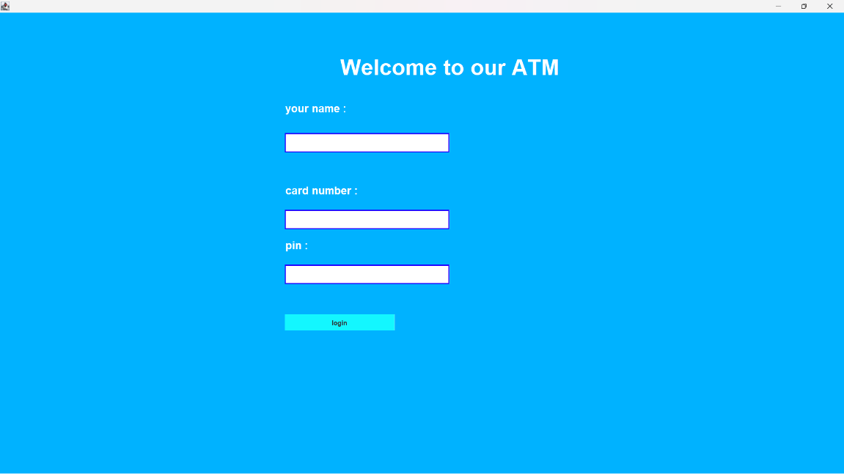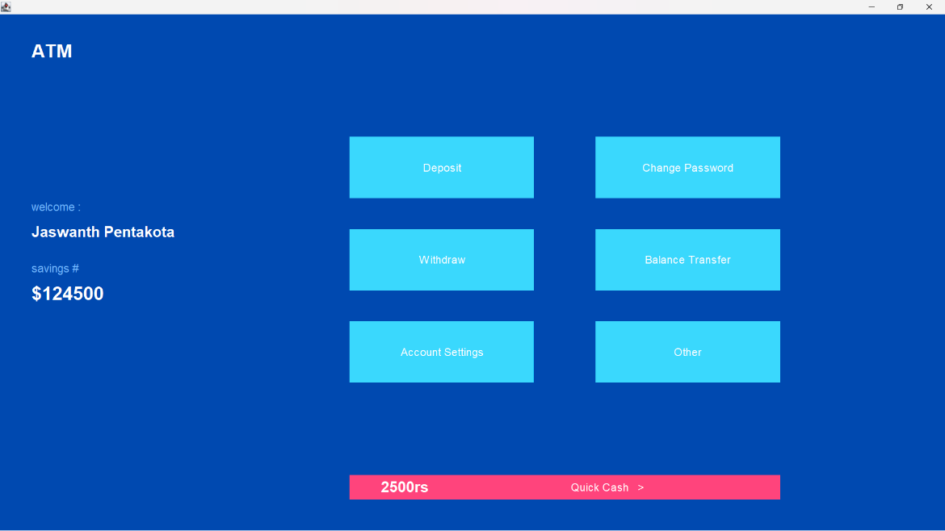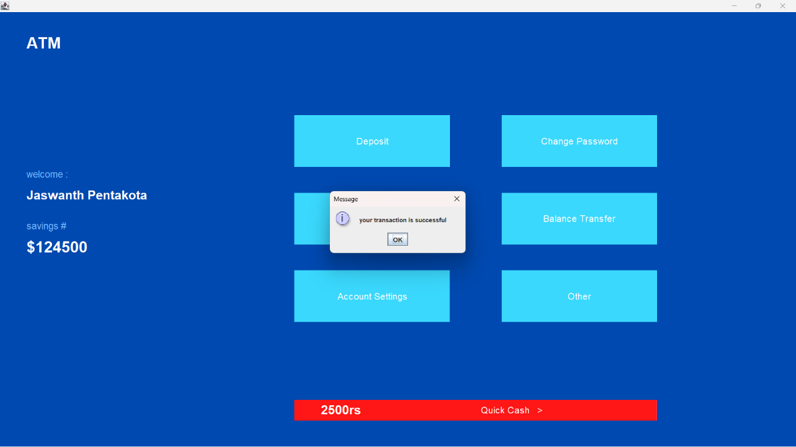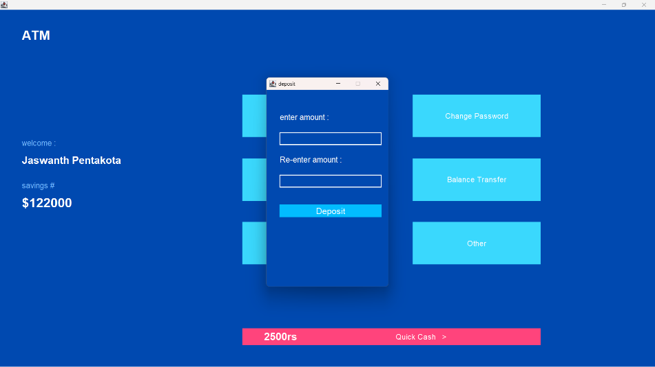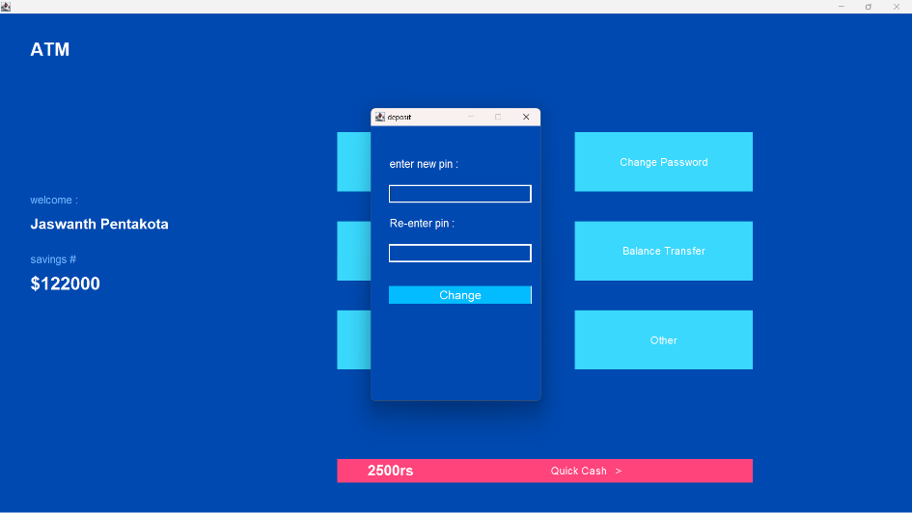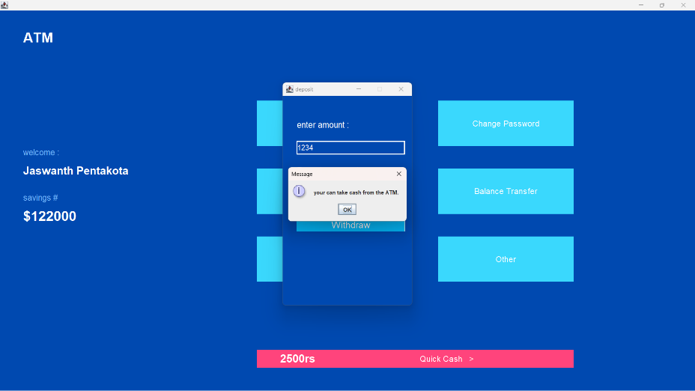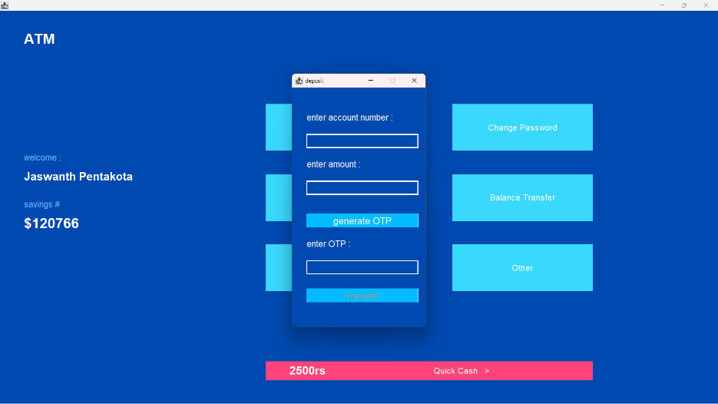

**DATA FLOW DIAGRAM**

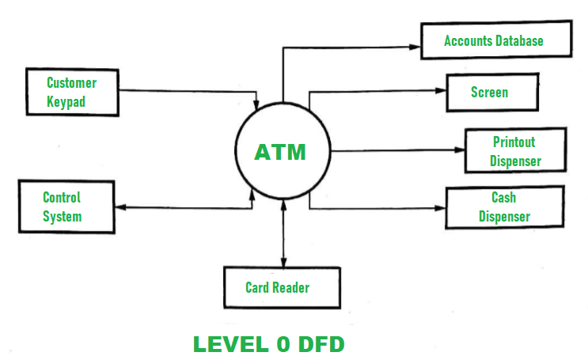

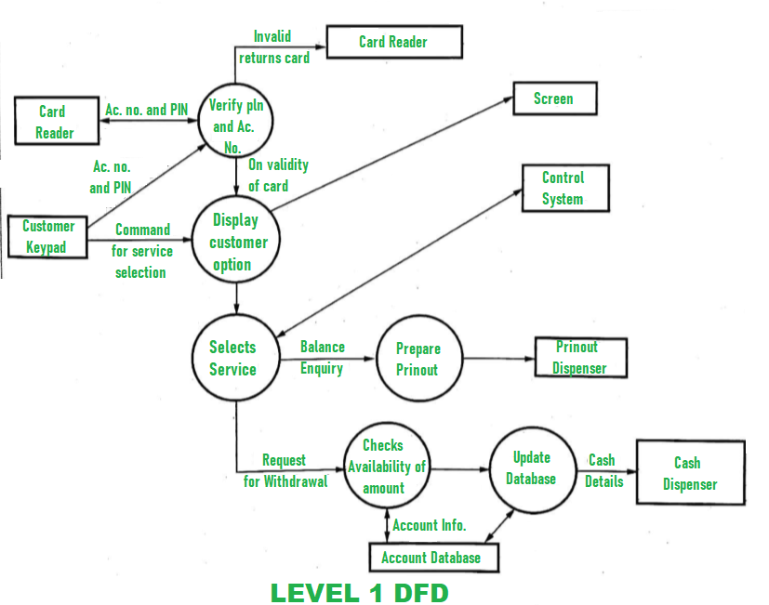

**USE CASE DIAGRAM**

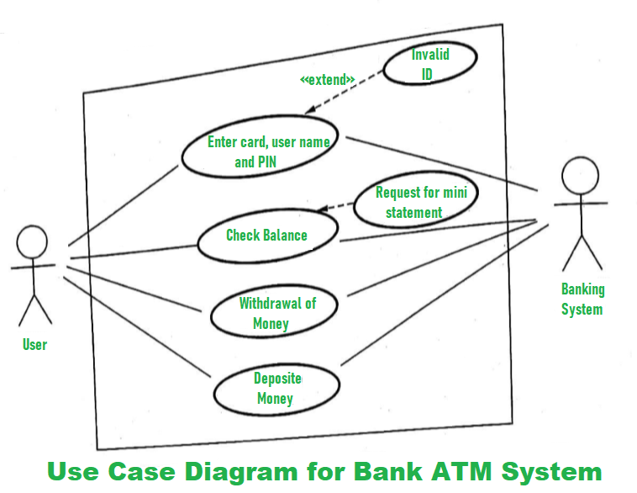

**Use Case Diagram for Customer Authentication:**

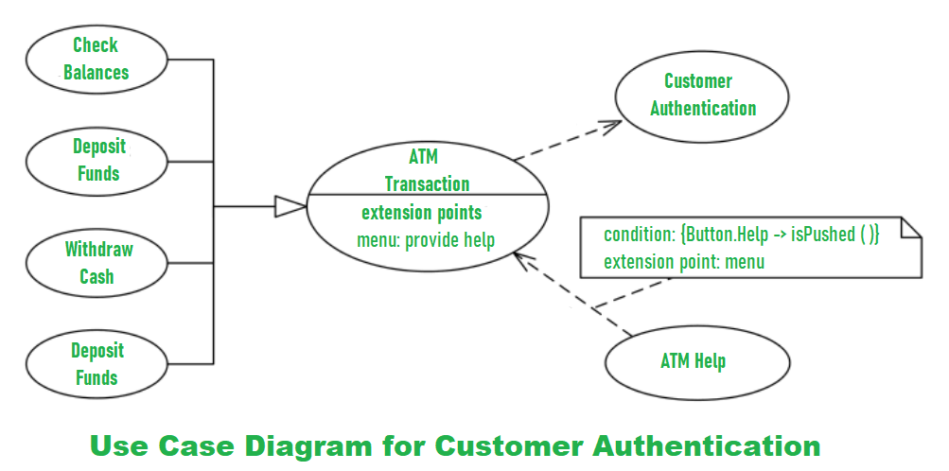

**Use Case Diagram for ATM Technician:**

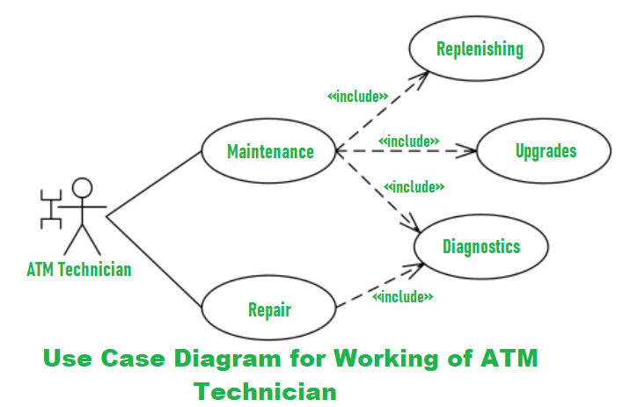

**STATE TRANSITION DIAGRAM**

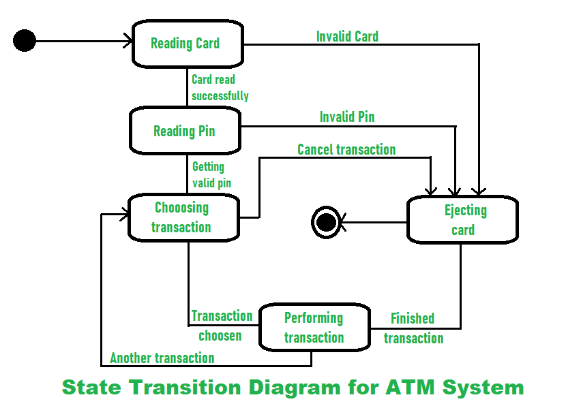

**ER Diagram of ATM Management System**

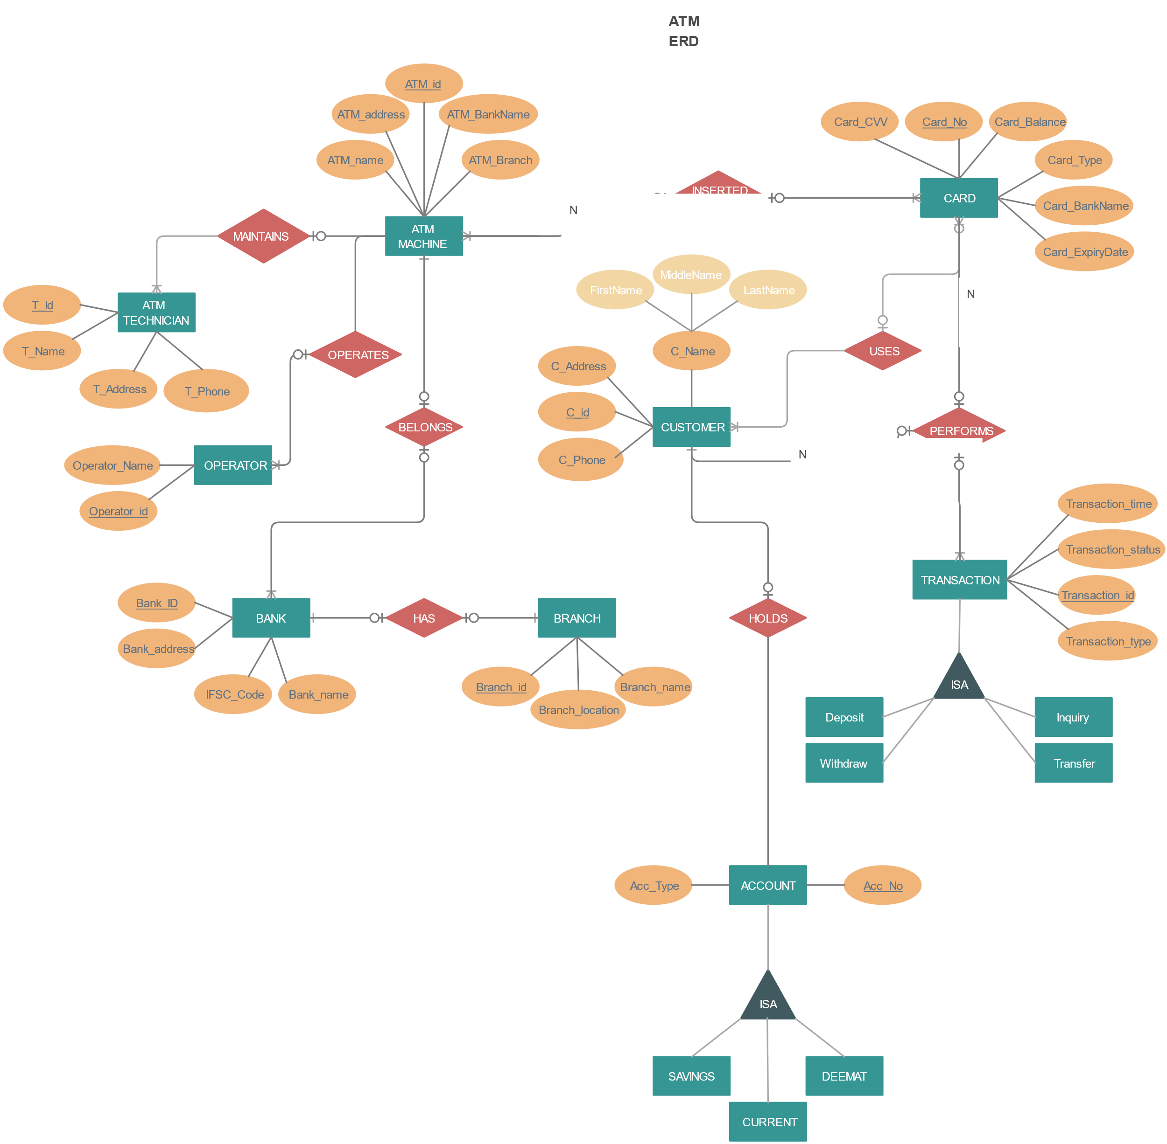

**GANTT CHART:**

Progress of work schedule in terms of Gantt Chart

|  |  |  |  |  |  |
| --- | --- | --- | --- | --- | --- |
| **Task Name** | **Start Date** | **End Date** | **Duration (Days)** | **Days Complete** | **Precent complete** |
| Requirement Analysis | 04/03/23 | 06/03/23 | 3 | 3 | 100% |
| Designing | 07/03/23 | 10/03/23 | 4 | 4 | 100% |
| Coding | 16/03/23 | 10/04/23 | 25 | 25 | 100% |
| Testing | 10/04/22 | 16/04/23 | 6 | 6 | 100% |

**Conclusion:**

The ATM Management System is a software application developed in Java language to provide the user with a convenient and secure method for accessing their bank accounts. The system is designed to work with any standard ATM machine and offers features like balance inquiry, withdrawal, deposit, PIN change, and transaction history. The system is developed using Java Swing for the user interface and MySQL database for storing account information and transaction history. The system can improve the efficiency and accuracy of banking operations and minimize errors and frauds in the banking system.